**WEB DESIGN**

**PROJECT REPORT**

|  |  |
| --- | --- |
| **PROJECT TEAM** | |
| **Student No.** | **Student Names** |
| **x16134613** | **Nassima Kara** |
| **x16135083** | **Benjamin Adeline** |
| **X16138457** | **Lorenzo Cipriani** |

**\*\* Sales Web Site Latte e Biscotti \*\***

**Final website:**

[**http://project.lattebiscotti.com**](http://project.lattebiscotti.com)

**Project workspace:**

[**https://github.com/lorenzocipriani/website-demo**](https://github.com/lorenzocipriani/website-demo)

**Acknowledgements**

We would like to thank the founder and CEO Barbara Cipriani for building the first version of the website for Latte et Biscotti.

**Section 1: Design**

1. PROJECT PROPOSAL

## Project Overview

Latte e Biscotti is a growing italian company mainly specialised in the production and sales of clothes and shoes suitable for babies and children until the age of 12. The brand does not have any online presence except the company accounts in some social network such as Facebook, Instagram and Twitter. To face the needs of the customers and challenges of a growing demand, the owner of the company wishes to create a sales website where the customers and retailers can experience the Latte e Biscotti brand online across Europe and the United States.

The owner outlined some specific goals for this website:

* Introduce all the Latte e Biscotti products online to the customers and retailers;
* Increase the upselling and cross-selling by structuring the online offering;
* Attract new customers and grow the existing client’s base through their online presence;
* Automate and simplify the sales process to reduce the costs/time to complete a sale and improve the customers’ satisfaction.

To respond to the basic requirements, the preliminary plan consists in building an interface that will help the customers and retailers:

* To know more about Latte e Biscotti and its expertise.
* To view the collections and other offerings in their dedicated web pages;
* To make an order and payment, view and review their order history;
* To contact Latte e Biscotti;
* To have an overview of the Terms and Conditions, Shipping and Delivery policies, FAQ;
* To follow the company Latte e Biscotti on the social networks such as Facebook, Instagram and Twitter.

## Research / Investigation

In the preliminary phase of our research, we carried out our research through the websites of the biggest brands in the childcare segment:

* Jacadi: http://www.jacadi.com/en
* Petit Bateau: http://www.jacadi.com/en
* Tartine et Chocolat: http://www.tartine-et-chocolat.fr/fr-fr/

We established some researches according to the criteria that can be considered as important from a customer experience perspective. Overall, the three sites are using a hoverable dropdown menu in the navigation bar to ease the exploration of the catalog by the customer. An efficient search form is available at the top of the Petit Bateau and Tartine au Chocolat websites as it can help to go directly to a product associated with the different variants offered by the brand. However, Jacadi and Petit Bateau are not using any written efficiently to enhance the home page while the Tartine au Chocolat website finds an excellent balance between the graphic design and the descriptive content. The bottom of the websites are generally used to reference information about terms and conditions, delivery which is poor in the Jacadi home page. Eventually, the accessibility and privacy are part of the home page in the Petit Bateau and Tartine au Chocolat, the customers have the possibility to visit the website through their own account. The table below summarize the results of our researches across these three websites:

|  |  |  |  |
| --- | --- | --- | --- |
| Benchmarking criteria | Jacadi | Petit Bateau | Tartine et Chocolat |
| Overall Quality | Average | Good | Excellent |
| Navigation menu | Good | Excellent | Excellent |
| Search | Average | Excellent | Excellent |
| Usability | Average | Average | Excellent |
| Written Content | Average | Weak | Excellent |
| Bottom of the website | Average | Good | Excellent |
| Accessibility | Average | Average | Excellent |
| Privacy | Poor | Good | Excellent |

During our research, the Mothercare website has been integrated in our scope. Because of the growth, it is difficult to navigate through some websites as they contain too much information, options or photos. The excess of automation can be an explanation of this trend. Following our first meeting, we understand that the customer is still developing their positioning in the marketplace, therefore the purpose of the website is to develop an online marketing strategy with the customers and retailers. The approach that will be adopted is centered on a customer-centric interface focused on the presentation of the collections and the communication with the company. The purpose is also to associate the quality of the products with the identity of the brand through the customer experience.

## Requirements & Technical Approach

Once the business requirements have been analysed, the team approached the project from a technical perspective by using the UML case diagram to define the scope of the system, the list of system functionalities and the interactions between the system and the possible actors in the system. The system of the sales web site requested by Latte e Biscotti is defined by the following case diagram:

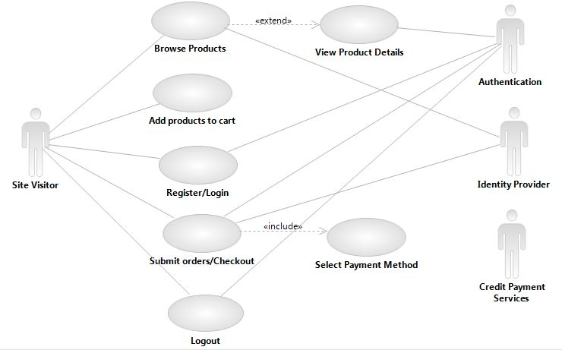

The main actor is the visitor (customer or retailer). The other actors are proceeding to the authentication during the creation of an account, the login/logout. The credit payment services is used during the last step of the sales transaction.

Based on the diagram, we can identify the main group of activities:

1. The visitor browses the products online and review the details of the products (type, age, season)
2. The visitor adds the products to the cart
3. The visitor is registering his account if he is a new customer. If the visitor is a retailer, this step would happen as soon as he is entering in the retail area.
4. The visitor is logging in his accounts if he is already a customer or retailer
5. The visitor is checking out
6. The visitor is logging out

After a review of the UML diagram, the team worked on the elaboration of few examples of UML classes. We agreed on the first mock-up and sitemap that should be presented to the company owner. The initial plan is to develop three versions of the web pages respectively for a web browser, an iPhone and a tablet.

## WIREFRAME / SITEMAP

As a result of the preliminary plan, the wireframe and sitemap of the website have been aligned to the objectives of Latte e Biscotti established in the previous section as follows:

|  |  |
| --- | --- |
| Web page | Preliminary structure of the website |
| Home page | The home page is the landing page where the visitors will be able to access to the information about the company, the products and search for a store across Europe and the United States. The visitors will have the possibility to access their dedicated space through two options: Customers or Retailers |
| About Us | This page presents the story of the company Latte e Biscotti since its creation and advertise the benefits of buying the Latte e Biscotti products (Know-How, quality of the fabrics, expertise) |
| The Collections main page for customers | The web page is offering the customers or retailers to access the following pages:   * About Us * The Collections * Sales * Find a Store   The customer will have the possibility to browse the collection or sales by three categories (Age, Type and Season) or Make A Gift.  The customer has the possibility to make an order through a specific form, view his orders and review his order history. |
| The Collections main page for the retailers | The web page is offering the customers or retailers to access the following pages:   * The Collections * Sales * Make an Order * Contact us (Form, Email or Phone)   The retailer will have the possibility to browse the collection or sales by three categories (Age, Type and Season).  The retailer has the possibility to make an order through a specific form, view his orders and review his order history. |
| Find a store | This page will help the visitor to locate a store across Europe and the United States |
| Sign in Sign out/Register page | This page will help to identify the type of visitor and redirect them to their dedicated space where they can login or register |

“The Collections” web page presents the products by season for the following segments of customers:

* Babies (0 – 6 months);
* Toddlers (6months – 36 months);
* Children (Above 36 months to 12 years);
* The shoes;
* The Home Collection of the Latte e Biscotti brand

While viewing the products, the customers and retailers will have the possibility to order online.

The main web page “The Collections” is also offering the option to “Make a gift” through online vouchers in the customer area only.

The footer in each web page will contain a link to the web pages related to the following topics:

* Terms and Conditions;
* Shipping and Delivery;
* FAQ (Frequently Asked Questions);
* Legal notice.

A loyalty space will be created to offer the option of joining the “Latte e Biscotti” in Facebook, Twitter and Instagram.

The following sitemap and wireframe are the result of the researches and requirements from the customer. The navigation tree is structured according the hierarchy listed in the following sitemap :

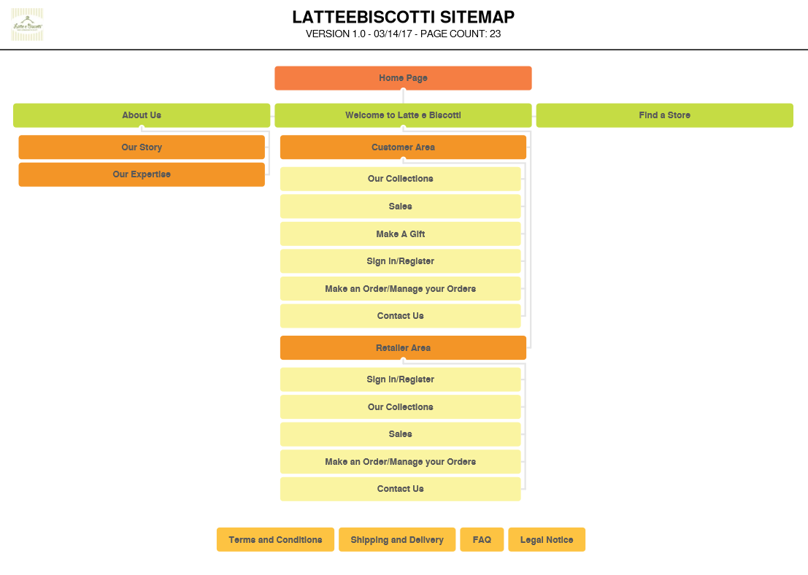

Following the analysis of the customer requirements, we decided to use three wireframes depending on the purpose of the pages

* Wireframe 1: Homepage

Menu Bar

Header

Footer

Content

* Wireframe 2: About Us pages and Customer Support Wireframe

Menu Bar

Header

Sidebar

Sidebar

Footer

Content

* Wireframe 3: Shopping pages

Sidebar

Footer

Content

Menu Bar

**Section 2: Development**

1. **PRODUCTION LOG**

The construction of a website requires gathering the requirements, evaluate their feasibility in the allocated timeframe, designing and implementing the design.

1. **Analysis of the business and technical requirements**

The first step of the definition of the requirements with the company Latte e Biscotti during our first meeting with the founder of the company, Barbara Cipriani. She outlined the following points:

* Story of Latte e Biscotti, a growing company
* The target of the website: end-user customers and retailers
* Purpose and type of the website: sales website for both audience
* The presentation of her brand and her expectations

The second step focused on the approach that should be adopted in the design of the websites and webpages. We reviewed the following points:

7th March 2017

* Completion of the wireframes:
* 1 for the homepage,
* 1 for the shopping pages
* 1 for the presentation and customer services pages

-The navigation tree across the website

-The detailed mock-ups that we decided to build for the web browsers, iphone and ipad.

The third step consisted in developing the first codes which would represent the basic implementation of the mock-ups at the end of march 2017.

21st March

* Completion of the first version of the end-users pages

6th April 2017

* Completion of the first version of the retailers pages

A detailed review/assessment of the pages has been done against the criteria required set up by the customer during the project. Here are the specific areas of the reviews:

* Design of the wireframes with Bootstrap

As far as we started the coding, the risk is to deviate from the initial plan and end up with a complete different structure. Wireframing consists in structuring the content of the pages according to a hierarchy that will improve the user experience. We learned how to structure the pages based on the Boostrap grid system comprising 12 columns across the page.

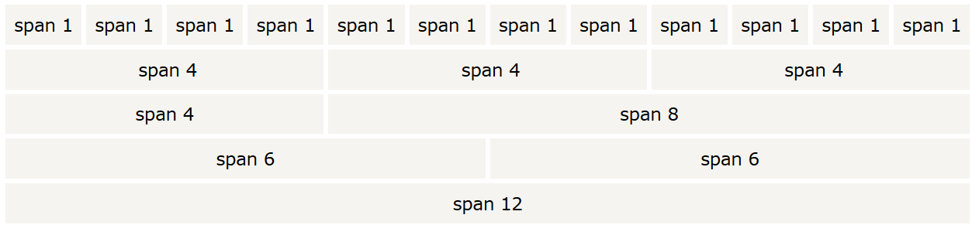

The tutorial of W3 school outlines that Bootstrap's grid system is responsive, and the columns will re-arrange depending on the screen size. Boostrap offers four classes:

* xs (for phones)
* sm (for tablets)
* md (for desktops)
* lg (for larger desktops)

Initially, we started the coding without using Boostrap, however we decided to change to make the pages more responsive. We design the layout of the three wireframe as follows:

**Main Page:**

Menu Bar: 12 columns on top of the page

Header: 12 columns below the menu bar

Main Content: 12 columns

Footer: 12 columns

**Presentation pages and Customer Service pages:**

Menu Bar: 12 columns on top of the page

Header: 12 columns below the menu bar

Main Content: 8 columns

Sidebar left: 2 columns

Sidebar right: 2 columns

Footer: 12 columns

**Shopping pages:**

Menu Bar: 12 columns on top of the page

Header: 12 columns below the menu bar

Main Content: 10 columns

Sidebar left: 2 columns

Footer: 12 columns

As the shopping pages, would introduce the offerings of Latte e Biscotti to the customers and retailers, we judged that more space would be required from that perspective. In term of responsiveness, we also looked at bootstrap grid options that shows how Boostrap works across all the devices (Appendix A).

Eventually, we adapted the code that were initially written to the Boostrap. For example, the rows have been coded as .container (fixed width) or .container-fluid (full width).

* Design of the navigation bar, header and the social media footer

The preliminary research about the web pages of the big companies defined the trends used in this industry in the web design field. For example, most of the navigation bars are dropdown menus displayed with the inline-block attribute. We wanted to adopt the same structure, however it is not exactly adapted to the current business case.

It was also challenging to find a background that is complimentary with the colour of the Latte e Biscotti logo. We looked at the possible scenarios based on some colour calculators in some graphic design websites such as sessionscollege for professional design. We eventually come back to the black and white option that is adapted to any type of content.

Regarding the social media footer, there was a dilemma as multiple options are available for the icons representing the social media networks. Again, it has been decided that we will use the original icons linked to the Latte e Biscotti accounts across Twitter, Instagram, Facebook and Pinterest.

* Review of the Javascripts used in webpages

Even though we are using Javascript on a daily basis as a consumer, it seems more complex to implement Javascript.

The first javascript code that we used is the slideshow presenting Latte e Biscotti on the main page and the section “our story”. Indeed, it is an excellent substitute to a video as the company has not produced any video content until now.

The second javascript code used is the “accordion” that contribute to the structure of the information in the customer service pages.

The third javascript code is the Google map positioning Latte e Biscotti in Italy.

* Importance of the responsiveness of the pages

The last critical topic is the responsiveness of the pages, it is part of our requirement to make all the pages responsive across the web browsers, phones and ipad. It is a recurrent topic as the content also defines the responsiveness of the pages. Several factors contribute to the elasticity of the interface such as CSS, the definition of the layouts around the four classes that we outlined previously and the quality of the coding.

* The technical requirements of the project

To achieve the goal of the project, the following tools will be used in the different steps of the project:

Definition of the mockups and wireframe: Balsamiq

Coding: Brackets

Version control repository: Git

Gear host: Hosting of the website

1. **Validation**

Prior the validation of the pages, we worked on formatting correctly the codes for each pages.Here is the validation report of the website:

* Validation of the Homepage:

|  |  |
| --- | --- |
| File name | Report from W3 Validator |
| Homepage Index.html | Document checking completed. No errors or warnings to show. |

* Validation of the presentation and customer service pages:

We validated 14 pages that focus on the presentation of the company and the customer service:

|  |  |
| --- | --- |
| File name | Report from W3 Validator |
| Ourstory.html | Document checking completed. No errors or warnings to show. |
| Ourexpertise.html | Document checking completed. No errors or warnings to show. |
| Ourproducts.html | Document checking completed. No errors or warnings to show. |
| Ourteam.html | Document checking completed. No errors or warnings to show. |
| Contactus.html | 2 errors. Screenshot enclosed below the table |
| Endusefaq.html | Document checking completed. No errors or warnings to show. |
| Endusrelegalnotice.html | Document checking completed. No errors or warnings to show. |
| Retailerlegalnotice.html | Document checking completed. No errors or warnings to show. |
| Retailershipping.html | Document checking completed. No errors or warnings to show. |
| Retailerterms.html | Document checking completed. No errors or warnings to show. |
| Enduserfindastore.html | Document checking completed. No errors or warnings to show. |
| Enduserfindastoreonlinestores.html | Document checking completed. No errors or warnings to show. |
| Enduserfindastorepartners.html | Document checking completed. No errors or warnings to show. |
| Sitemap | Document checking completed. No errors or warnings to show. |

* Page Contact Us

Issue 1: The div element is not allowed as child element of ul. This mistake appeared in all the pages as the closing of one div element was missing.

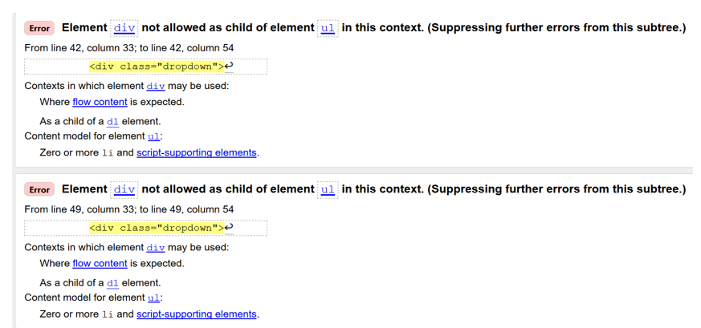

Solution:

<div class="nav navbar-nav navbar-right">

<div class="dropdown">

<span class="glyphicon glyphicon-log-in" style="color:ghostwhite;"></span><button class="dropbtn"> Your Account</button>

<div class="dropdown-content">

<a href="endusersignform.html">Sign in</a>

<a href="enduserregisterform.html">Register</a>

</div>

</div>

<div class="dropdown">

<span class="glyphicon glyphicon-shopping-cart" style="color:ghostwhite;"></span><button class="dropbtn">Checkout</button>

<div class="dropdown-content">

</div>

</div>

</div>

Issue 2: The button must not appear as a descendent of the a element

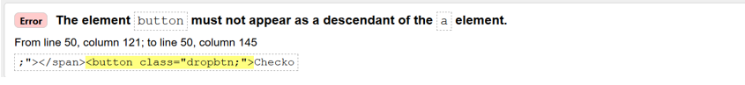

<span class="glyphicon glyphicon-shopping-cart" style="color:ghostwhite;"></span><button class="dropbtn">Checkout</button>

Solution: Removal of the a element that is not relevant.

* Validation of the end-user pages:

We validated 12 pages that are specialized in the offerings for the end-users.

|  |  |
| --- | --- |
| File name | Report from W3 Validator |
| Endusercollectionsbaby.html | 3 errors. Screenshot enclosed below the table |
| Endusercollectionschildren.html | Document checking completed. No errors or warnings to show. |
| Endusercollectionshome.html | Document checking completed. No errors or warnings to show. |
| Endusercollectionsmainpage.html | Document checking completed. No errors or warnings to show. |
| Endusercollectionssales.html | Document checking completed. No errors or warnings to show. |
| Endusercollectionsshoes.html | Document checking completed. No errors or warnings to show. |
| Enduserfamilyandfriends.html | 2 errors. Screenshot enclosed below the table |
| Endusermakegift.html | Document checking completed. No errors or warnings to show. |
| Enduserregisterform.html | Document checking completed. No errors or warnings to show. |
| Enduserregisterformnext.html | Document checking completed. No errors or warnings to show. |
| Endusersignform.html | Document checking completed. No errors or warnings to show. |
| Endusersignformreset.html | Document checking completed. No errors or warnings to show. |

* Issue 1: Family & Friends page – Duplicate ID



The id tag for the images has not been used appropriately. According to the tutorial W3 School, the id attribute specifies a unique id for an HTML element (the value must be unique within the HTML document). The tutorial outlines that the id attribute is most used to point to a style in a style sheet, and by JavaScript (via the HTML DOM) to manipulate the element with the specific id.

Solution: The tag has been removed as it is not relevant

* Issue 2: Family & Friends page – Duplicate ID



The id tag for the section has not been used appropriately. According to the tutorial W3 School, the id attribute specifies a unique id for an HTML element (the value must be unique within the HTML document). The tutorial outlines that the id attribute is most used to point to a style in a style sheet, and by JavaScript (via the HTML DOM) to manipulate the element with the specific id.

Solution: The tag has been changed to class.

<p class="ourcollections"><a href="endusercollectionsmainpage.html">Our Collections</a></p>

* Issue 3: Endusercollectionsbaby page – The childs of the ul elements

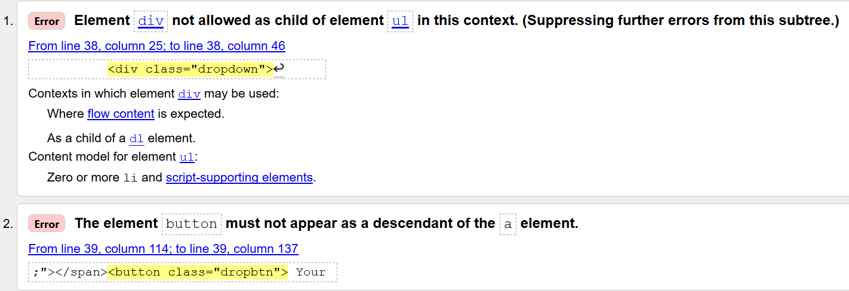

Solution:

<div class="nav navbar-nav navbar-right">

<div class="dropdown">

<span class="glyphicon glyphicon-log-in" style="color:ghostwhite;"></span><button class="dropbtn"> Your Account</button>

<div class="dropdown-content">

<a href="endusersignform.html">Sign in</a>

<a href="enduserregisterform.html">Register</a>

</div>

</div>

<div class="dropdown">

<span class="glyphicon glyphicon-shopping-cart" style="color:ghostwhite;"></span><button class="dropbtn">Checkout</button>

<div class="dropdown-content">

</div>

</div>

</div>

Some closing elements were missing in the initial code, the mistakes have been corrected. According to the W3 Consortium, the ul element is part of the grouping tags similarly to the <div> element, as a result it can be an issue to have both elements in the same section of code.

* Validation of the retailer pages:

|  |  |
| --- | --- |
| File name | Report from W3 Validator |
| Retailercollectionsmainpage.html | Document checking completed. No errors or warnings to show. |
| Retailercollectionshome.html | Document checking completed. No errors or warnings to show. |
| Retailercollectionschildren.html | Document checking completed. No errors or warnings to show. |
| Retailercollectionsbaby.html | Document checking completed. No errors or warnings to show. |
| Retailercollectionsshoes.html | Document checking completed. No errors or warnings to show. |
| Retailerregisterformnext.html | Document checking completed. No errors or warnings to show. |
| Retailersignform.html | 2 errors. Screenshot enclosed below the table |

* Issue 2: Retailsiginform – The child element of the a tag

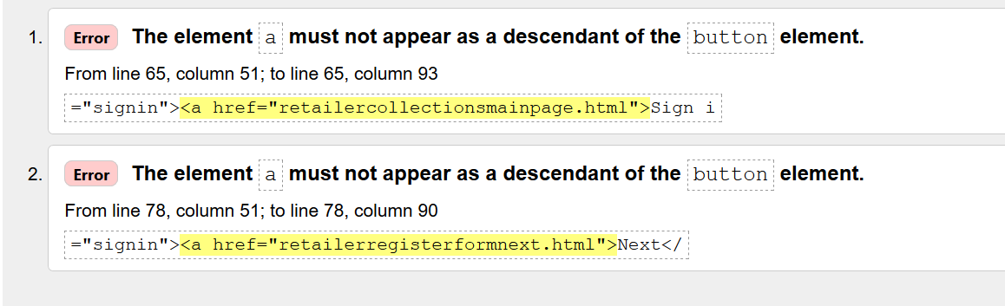

The code used is not correct. The **<button>** element should be used as it defines a clickable **button**:

Solution:

<form><input type="button" value="Sign in" onclick="window.location.href='retailercollectionsmainpage.html'" /></form>

1. **Deployment**

We currently used Gearhost to deploy the website project. GearHost is a Platform as a Service (PaaS) cloud built for .NET, PHP and Node.js developers who need to launch and scale applications (Gearhost, 2017). Here is the link to the website:

[**http://project.lattebiscotti.com**](http://project.lattebiscotti.com)

1. **PROJECT TEAM**

At the start of the project, we acknowledge the fact that the level within the team was heterogeneous and considered it as an opportunity for the non-practitioners to improve their learning curve in the web design area. Lorenzo Cipriani is an experienced software engineer while Nassima Kara and Benjamin Adeline are non-practitioners.

The tasks have been allocated in the team as follows:

|  |  |  |
| --- | --- | --- |
| Team members | Role | Tasks |
| Lorenzo Cipriani | Leader of the team | - Review the requirements and help the team to set up and review the action plan  -Periodical assessment the progress against the requirements/timeline with the two other team members  -Review of the code quality  -Implementation of the best practices  -Design/Coding of the Homepage |
| Nassima Kara | Team member | -Design/Coding of the pages under the mentoring of Lorenzo Cipriani  -Design of the web browser mock-up at the start of the project |
| Benjamin Adeline | Team member | -Design of the first version of the web pages for the retailers  -Design of the mock-up for the iphone and ipad version |

Evaluation of the teamwork:

The exercise in a group of non-practitioners can be challenging however Lorenzo wanted to implement the right methodology so that we reach the goals within the given timeframe of 2 months. After defining the goals and allocating the tasks, we divided the tasks. After designing the mockups with Balsamiq, we started coding the basic pages and reviewed with Lorenzo how we can improve. The collaboration was done through meetings but also the use of GitHub. Lorenzo Cipriani has been critical in this project. He brought a huge knowledge in the web design area. He challenged us in the web design area encouraging us to use the course and practice through Codeacademy regularly to gain competences and skills. The reviews were vital and efficient to move forward during the project.

1. **CONCLUSION**

The result of the project is satisfying if we consider the expectations of the customer that are high considering that it is in an industry with high standards. We believed that we achieved the basic goals set initially in the first meeting with the CEO and founder of the company. The learning point of this project was to adopt the website to the needs and requirements from the customer and not necessarily try to align with the current websites in the industry. If we had more time, we would refine the web pages by increasing our knowledge about the Javascript and use them as a marketing tool.

**REFERENCES & APPENDIX**

* **Books**

Robbins, J. 2007. Learning Web Design.O’Reilly Media Inc. United States.

Learning Web Design, A beginner’s guide to x(html), style sheets, and web graphics. Jennifer Niederst Robbins 3rd Editions

MacDonald, M.2011. HTML the missing manual. O’Reilly Media Inc., United States.

* **Online Resources**

**Gearhost. 2017. Frequently Asked Questions. [Online] Available :** <https://www.gearhost.com/faq> **[Last accessed 23rd April 2017]**

W3C. 2017. HTML/Elements/ul [Online]

Available: [https://www.w3.org/wiki/HTML/Elements/ul](https://www.w3.org/wiki/HTML/Elements/ul%20) [Last accessed 22nd April 2017]

W3C. 2017. HTML/Elements/ul [Online]

Available: <https://www.w3.org/wiki/HTML/Attributes/_Global> [Last accessed 22nd April 2017]

W3 Schools. 2017. HTML id Attributes. [Online]

Available: [https://www.w3schools.com/Tags/att_global_id.asp](https://www.w3schools.com/Tags/att_global_id.asp%20) [Last accessed 22nd April 2017]

W3 Schools. 2017. HTML form elements [Online]

Available: <https://www.w3schools.com/html/html_form_elements.asp> [Last accessed 22nd April 2017]

W3C Schools. 2017. Boostrap Grid System. [Online]

Available: <https://www.w3schools.com/bootstrap/bootstrap_grid_system.asp> [Last accessed 22nd April 2017].

Boostrap.2017. Boostrap Grid Examples. [Online]

Available : <https://getbootstrap.com/examples/grid/> [Last accessed 22nd April 2017]

* **Javascript Codes**

W3 schools. 2017. How TO - Collapsibles/Accordion. [Online]

Available: https://www.w3schools.com/howto/howto_js_accordion.asp [Last accessed 22nd April2017]

W3 schools.W3.CSS Slideshow.2017 [Online]

Available: https://www.w3schools.com/w3css/w3css_slideshow.asp [Last accessed April 2017]

Google. Google. 2017. Google Map Generator. [Online]

Available: http://www.googlemapsgenerator.com/en/ [Last accessed 22nd April2017]

## Appendix A: Bootstrap Grid Options

|  |  |  |  |  |
| --- | --- | --- | --- | --- |
|  | **Extra small devices Phones (<768px)** | **Small devices Tablets (>=768px)** | **Medium devices Desktops (>=992px)** | **Large devices Desktops (>=1200px)** |
| **Grid behaviour** | Horizontal at all times | Collapsed to start, horizontal above breakpoints | Collapsed to start, horizontal above breakpoints | Collapsed to start, horizontal above breakpoints |
| **Container width** | None (auto) | 750px | 970px | 1170px |
| **Class prefix** | .col-xs- | .col-sm- | .col-md- | .col-lg- |
| **Number of columns** | 12 | 12 | 12 | 12 |
| **Column width** | Auto | ~62px | ~81px | ~97px |
| **Gutter width** | 30px (15px on each side of a column) | 30px (15px on each side of a column) | 30px (15px on each side of a column) | 30px (15px on each side of a column) |
| **Nestable** | Yes | Yes | Yes | Yes |
| **Offsets** | Yes | Yes | Yes | Yes |
| **Column ordering** | Yes | Yes | Yes | Yes |

Source : W3C Schools. 2017. Boostrap Grid System. [Online]

Available: <https://www.w3schools.com/bootstrap/bootstrap_grid_system.asp> [Last accessed 22nd April 2017].